**Table of Contents**

**____________________________________________________________________________**

Acknowledgments 2

Abstract………………………………………………………………………………….2

Table of Contents……………………………………………………………………….3

List of Figures…………………………………………………………………………..3

Introduction……………………………………………………………………………..5

Flow Chart………………………………………………………………………………7

Design Development and Analysis……………………………………………………10

Discussion ……………………………………………………………………………..23

Conclusion……………………………………………………………………………..24

References and Bibliography………………………………………………………….24

# List of figures

Figure 1 Autonomous Robots [https://waypointrobotics.com/blog/what-autonomous-robots/] 5

Figure 2 Warehouse Robots [https://www.forbes.com/sites] 6

Figure 3 Security and Path management flow chart 7

Figure 4 Process management flow chart 8

Figure 5 CRUDE OIL PRICE 9

Figure 6 Front Panel (main panel of the system) 10

Figure 7 Order placement 11

Figure 8 a) Dialog and User Interface b) Order database 11

Figure 9 a) True case b) False case. 12

Figure 10 Indexing Path(SubVI) 12

Figure 11 Order Pickup and Processing 13

Figure 12 Slider control (Vertical and Horizontal) 13

Figure 13 SubVI and indexing 14

Figure 14 Case Structure 1 (Common path for all boxes) 15

Figure 15 Case Structure 2(Common path for Big and Small Box) and (Medium and Tiny Box) 15

Figure 16 Case Structure 3(Individual path) 15

Figure 17 Process Trolley 16

Figure 18 PROCESSING BLOCK DIAGRAM 16

Figure 19 Processing 17

Figure 20 Shipment Process 18

Figure 21 Block Diagram conveyer belt 18

Figure 22 Event report(SubVI) 18

Figure 23 Security Panel 19

Figure 24 Login Security 19

Figure 25 Security center block diagram 20

Figure 26 Crude and price conversion 20

Figure 27 Block diagram of Market SubVI 21

Figure 28 Date and Time SubVI 21

Figure 29 Web published VI 22

Figure 30 Web publishing tool 22

Figure 27 Web publishing tool………………………………………………………...22

# Introduction

As the robots are getting inevitable smarter every day through the advancement in the field of artificial intelligence and the Internet of things mostly know as IOT, things are changing at a rapid rate and so does the industry of the warehouse. As per report based on the growth of robot industry robots are going to boost logistics dramatically by year 2020[https://ifr.org/ifr-press-releases/news/ifr-forecast-1.7-million-new-robots-to-transform-the-worlds-factories-by-20]

And this boom can already be seen in many online companies such as Amazon electronic commerce who uses Amazon Robotics for its warehouse management and its already on the verge to be fully automated in just few years.

What are autonomous robot? The word Autonomous comes out from the word Autonomy which is the ability to make your own decision, for eg-Humans.So just like us Autonomous robots have the ability to make their own decisions and then perform an action accordingly. 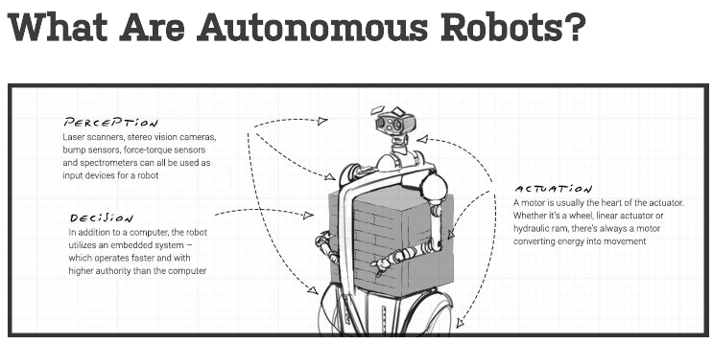

Figure 1 Autonomous Robots [https://waypointrobotics.com/blog/what-autonomous-robots/]

Autonomous robots can be used to improve the accuracy and speed of the operation which are being held on the routine basis, significantly in warehousing and manufacturing spaces, they will work as a collaborative robot working side by side with humans for better efficiency, making a large impact on the factor of employee safety.

In today’s world of online commerce, the most important thing is the customer satisfaction and Shipment easiness and fast delivery. This all things are managed in the warehouse of the companies and handling bulk of orders at the same time is not easy and prone to error if done by humans. So, with the revolution of autonomous robot they are programmed to work on the warehouse communication with other robots resulting in the less error and faster processing and 24hrs working environment.

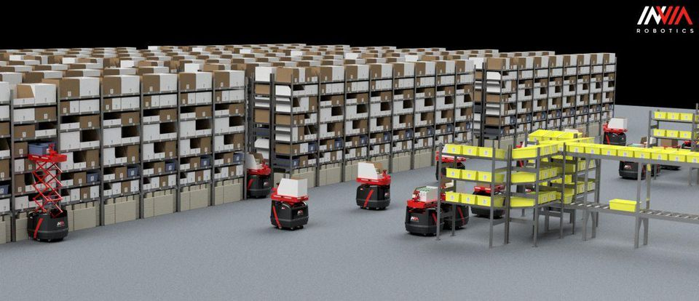

Figure 2 Warehouse Robots [https://www.forbes.com/sites]

As Machines cannot be autonomous by itself, behind every autonomous robots there is lot of programming done to make it complete autonomous. This report shows the logic and simulation done programmatically to simulate the Automated warehouse systems in LabVIEW programming language

LabVIEW (short for Laboratory Virtual Instrumentation Engineering Workbench) is a platform and development environment for a visual programming language from National Instruments. The graphical language is named "G". Originally released for the Apple Macintosh in 1986, LabVIEW is commonly used for data acquisition, instrument control, and industrial automation on a variety of platforms including Microsoft Windows, various flavours of UNIX, Linux, and Mac OS X.

LabVIEW is a dataflow programming language in which program execution is determined by the structure of a graphical block diagram (LV source code) on which the programmer connects different function-nodes by drawing wires,

# Flowchart

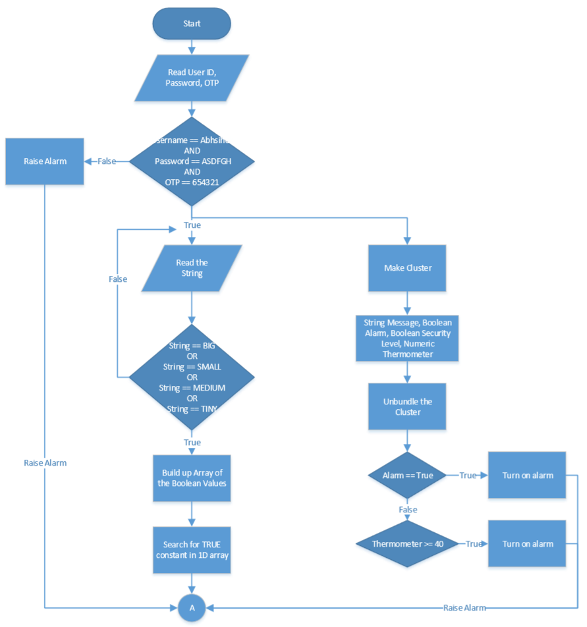

Figure 3 Security and Path management flow chart

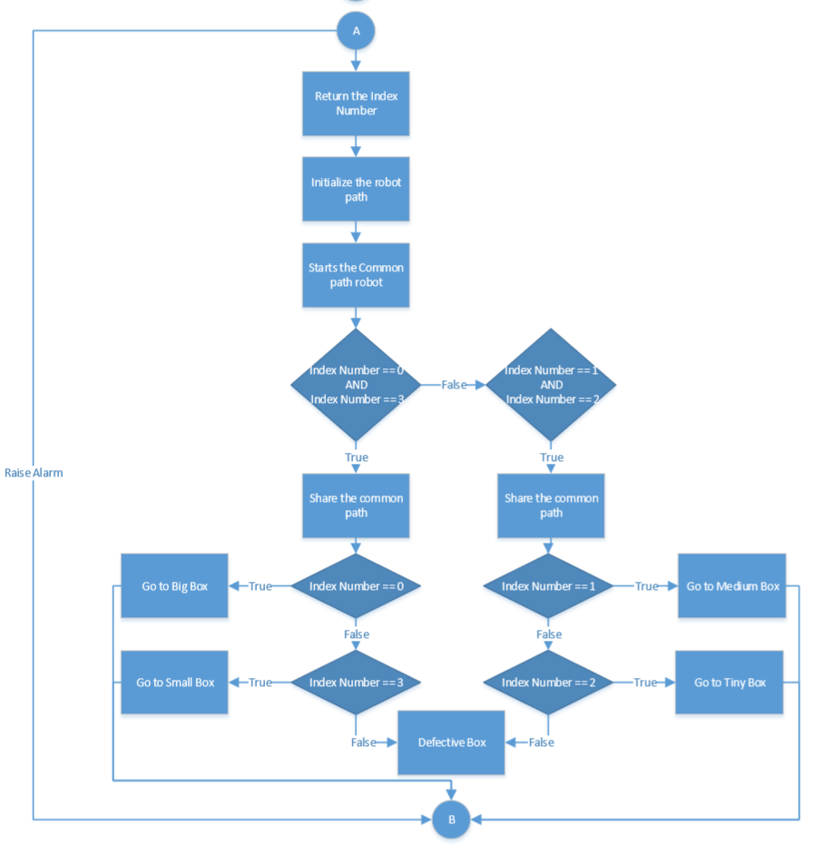

Figure 4 Process management flow chart

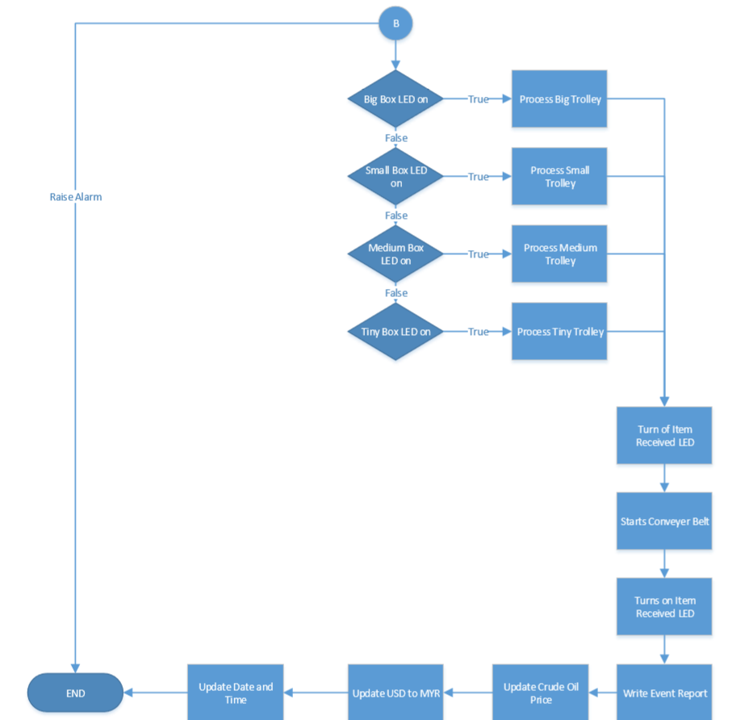

Figure 5 CRUDE OIL PRICE

# Design Development and Analysis

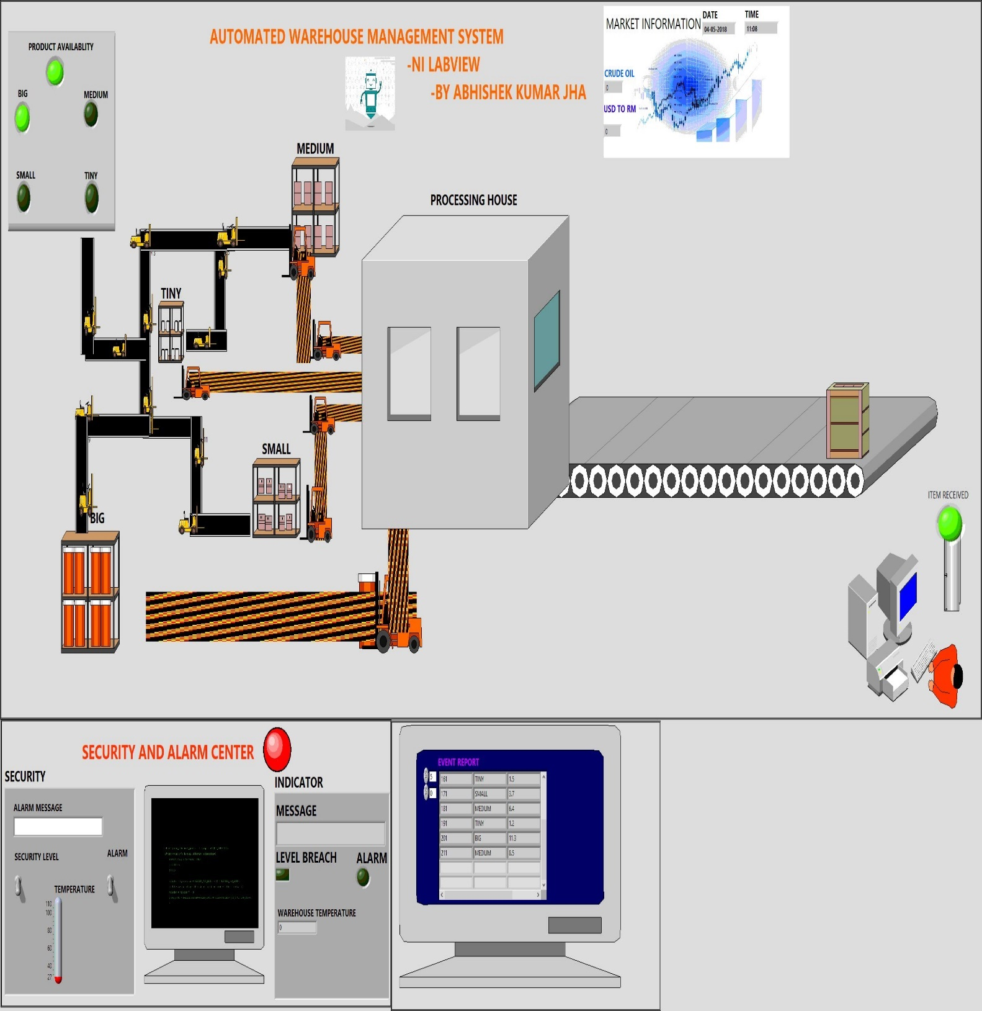

Figure 6 Front Panel (main panel of the system)

Mimicking the way of the process of warehouse management system and its step by step procedure which are: -

1)Order Placement.

2)Order Acknowledgement.

3)Order Pickup.

4)Order Sorting.

5)Order Processing.

6)Order Shipment.

The above Six steps are the step by step procedure followed in warehouse to run the system. So, for the main design of the system keeping all these steps in mind and extra functionality such as security, Event report and Crude oil price update and Money conversion this system is developed.

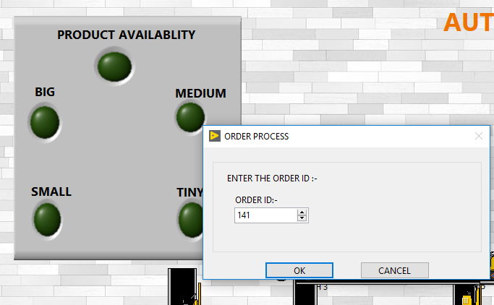

Figure 7 Order placement

For the Order placement (Figure 4), an Order id is provided which is b then processed from the Excel file to check whether the Order is available or not. As per the order id provided by the user the program check for the Order type and its weight for sorting out the order type and placing it further for processing.

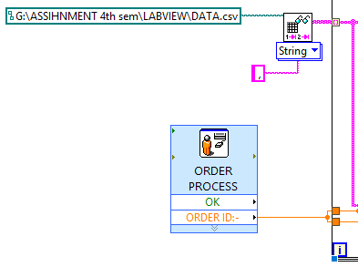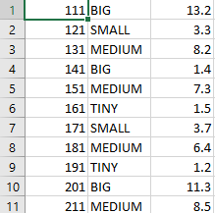

Figure 8 a) Dialog and User Interface b) Order database

Prompt User function (Figure 5 a) use by system to make the User dialog box, to let user enter the order id for placement and Read Delimited function being used to search from the path provided in the function for the data (Figure 5 b), this function takes a string for a file path and then use a specified delimiter to separate columns and then it returns value as per the index number provides. This design is more realistic for the order placement as the process flow for order placement works on the base of this design.

Next step is Order Acknowledgement and Order Sorting

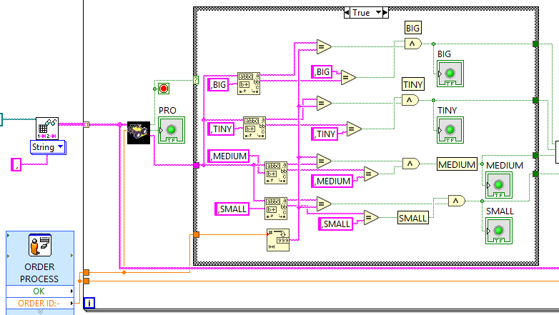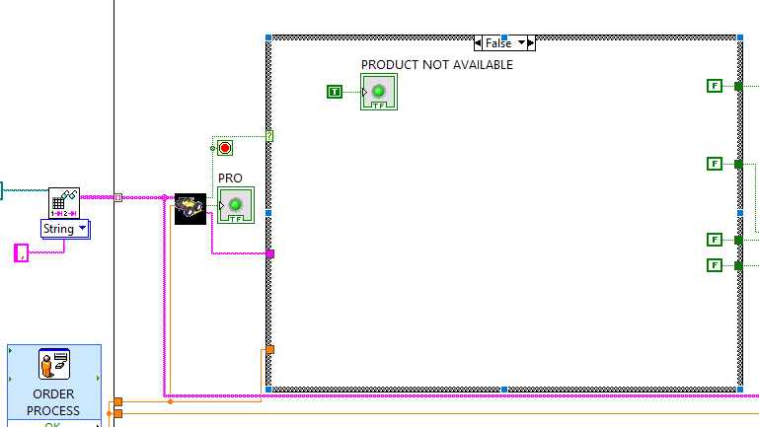

Figure 9 a) True case b) False case.

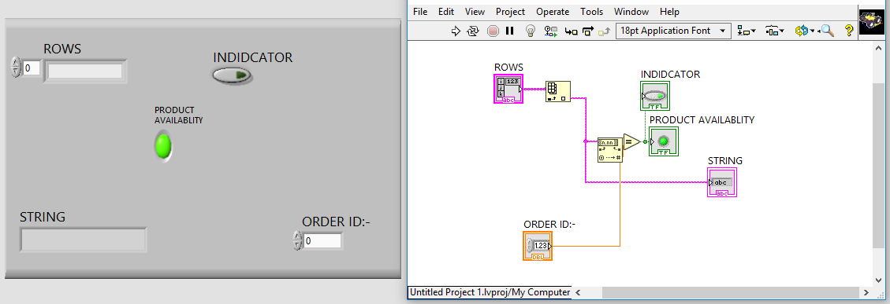

Figure 10 Indexing Path(SubVI)

For Order Acknowledgement system uses SubVI and a bunch of Boolean compare function and Boolean control function and with Array functionality. The Order id is match with the database and then uses a Boolean equals operator to check this is done in SubVI (Figure 7), A SubVI and then uses a Case Structure for Boolean output in which if the case is true it scans the second column from the database for sorting the Order id into four respective Categories (Figure 6 a) BIG MEDIUM SMALL and TINY. This are the sizes of the boxes. Sorting is done with the help of Match Pattern and an AND Compare function where is matches the scan string with the respective match string using Match pattern and then uses AND function for the comparison with the real string. whereas if the Case is False (Figure 6 b) it handles the error by Turning on the Boolean control product unavailability Or Defective Order.

Next step is Order Pickup and Order Processing

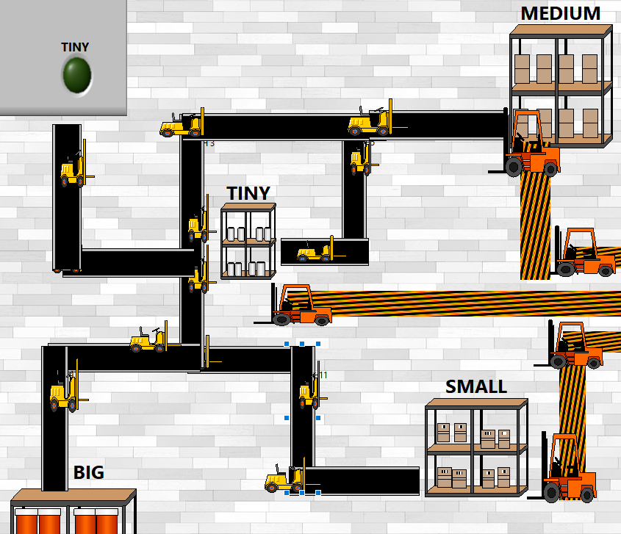

Figure 11 Order Pickup and Processing

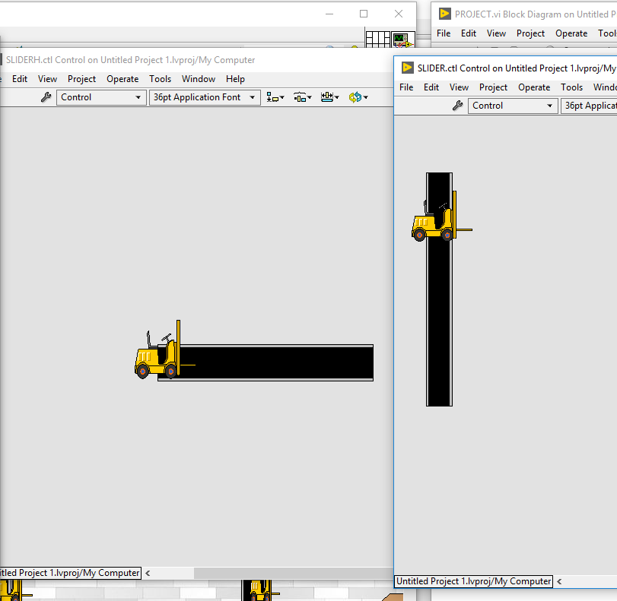

Figure 12 Slider control (Vertical and Horizontal)

After the order is sorted system uses Build Array function to store the results in Array and then uses the Search 1d array function to search for true case and then return the index number which is then used as a Shared variable function such that it can be accessed anywhere in the program as well can be informed in the web publishing tool this all is done in SubVI (Figure 10), If the case is false it return a -33-constant number as the error handling which is handled in next case Structure.

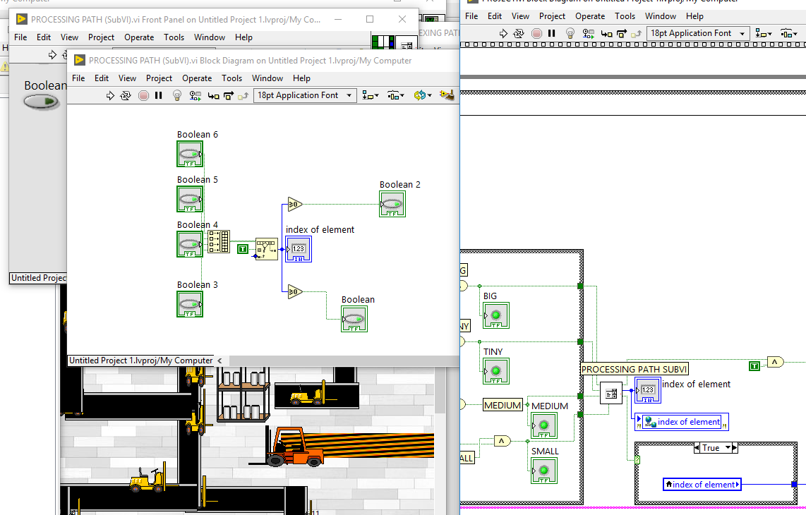

Figure 13 SubVI and indexing

For order Pickup system uses a Control VI (Figure 9) where it moves with the help of horizontal and vertical slider designed in the control panel, Also Program uses a flat sequence structure to make the program flow in a sequence and which also helps in debugging. As per the value return from the Shared Variable index the value passes to the Case structure.

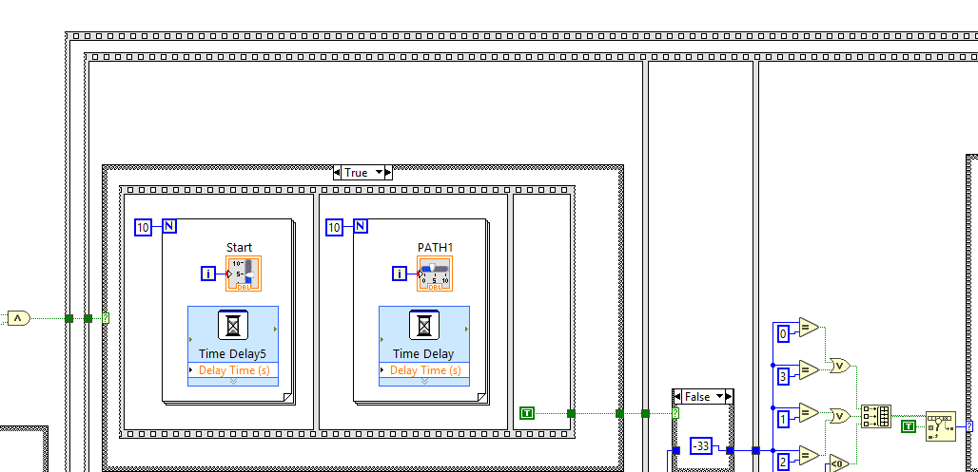

Figure 14 Case Structure 1 (Common path for all boxes)

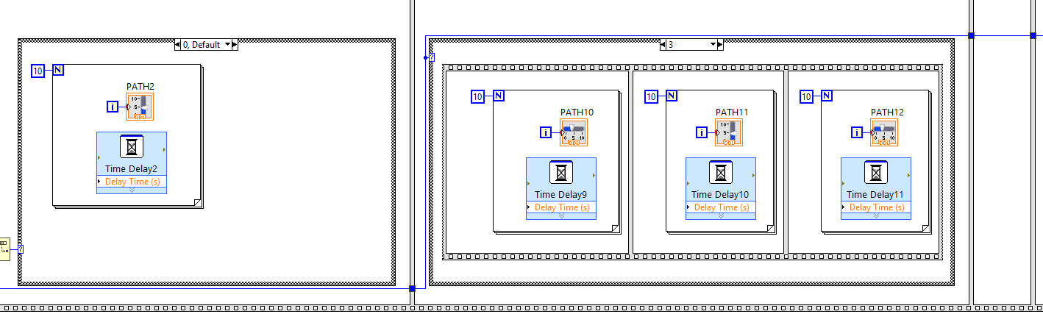

Figure 15 Case Structure 2(Common path for Big and Small Box) and (Medium and Tiny Box)

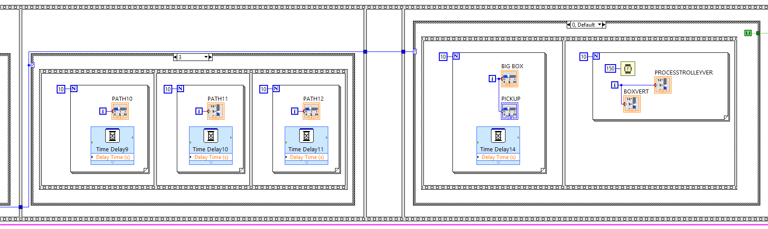

Figure 16 Case Structure 3(Individual path)

For placing the order to respective area, the robot have many common paths as for any order placed two robots have to take the same path for every box until first T path junction(Figure 11) likewise for Big and small box it(Figure 12) has to go through the same path and same for medium and tiny box so making the robots to be efficient the same path robots use the Same Case Structure until the diverted path(Figure 13) .And to make simulation of robots more real like system use Time Delay Function and the slider works under the While loop for 10 iteration to make every Robot move from a specific area to the desired area from Value 1 to 10 or elsewhere Robot moves in opposite direction the Values change from 10 to 1.

After the order reach the respective area another Trolley robot (Figure 14) use to send the package to shipping house for packaging and processing

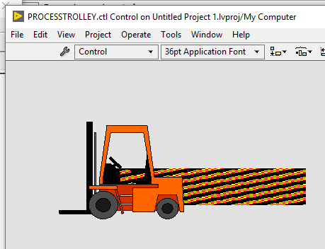

Figure 17 Process Trolley

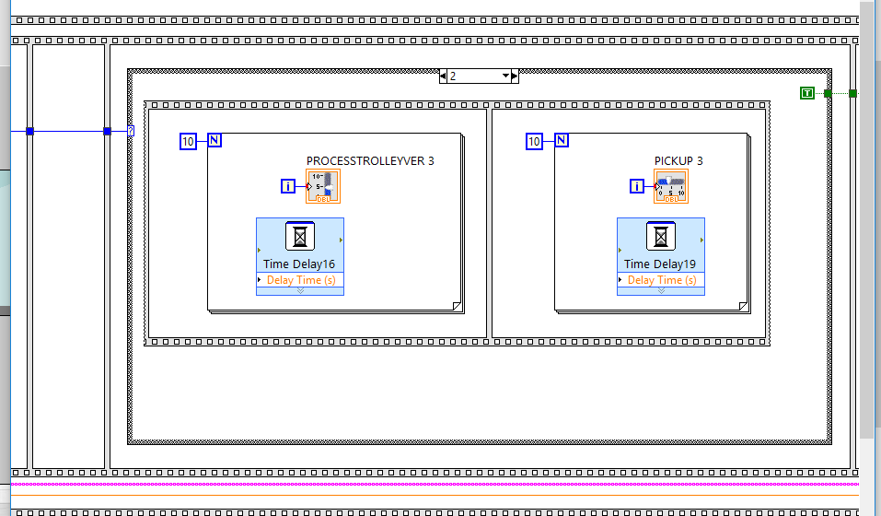

Figure 18 PROCESSING BLOCK DIAGRAM

The design of the trolley robot works on the same principle as the path robot, and it work as per the value received from the desire value which means as soon as the path robot drop the package a variable send a value to the Case Structure (Figure 15) have 4 cases as for 4 different boxes also the cases have while loop and flat sequence while loop is for iteration and flat sequence is for sequentially performing task, the Trolley Robot process the package to the Processing House (Figure 16) where the order is pack into the box for further shipping.

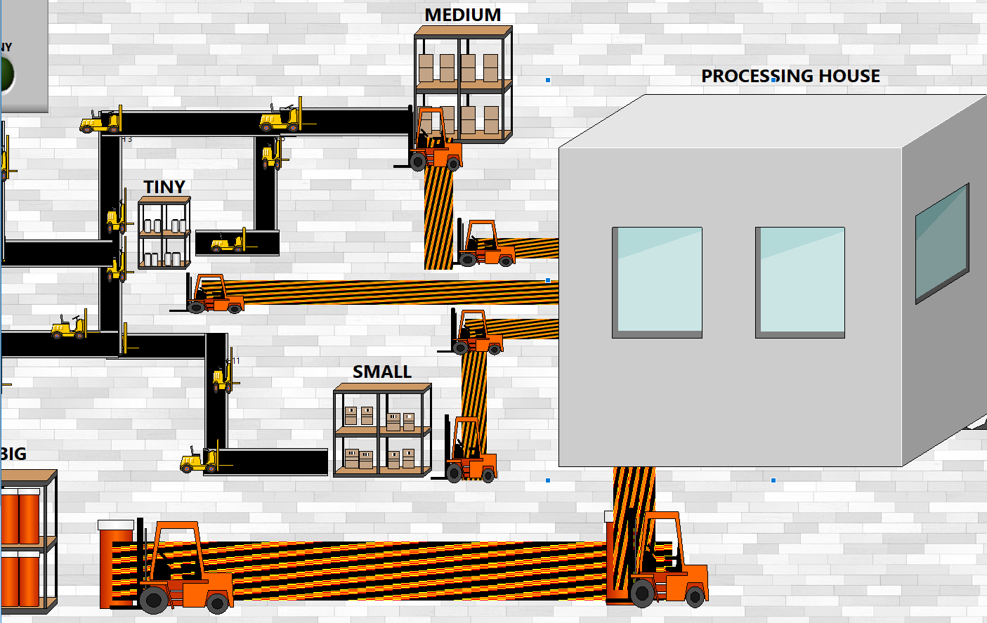

Figure 19 Processing

Last process is Order shipment (Figure 17).

After the box is pack system uses Conveyer belt (Figure 18) to send it for shipping zone for shipment and this is achieved by using a Boolean function to check whether the item is received or not as the Case Structure use in Conveyer belt send true value if the item is processed otherwise send false value which make the system to know there is no item received and the Boolean value turn to be false resulting in the off of Boolean led which notifies the system administrator about it. It does by making an Event report about it and it only makes the report if the item is received, by receiving the value from the case structure and the event report is done in SubVI (Figure 19).

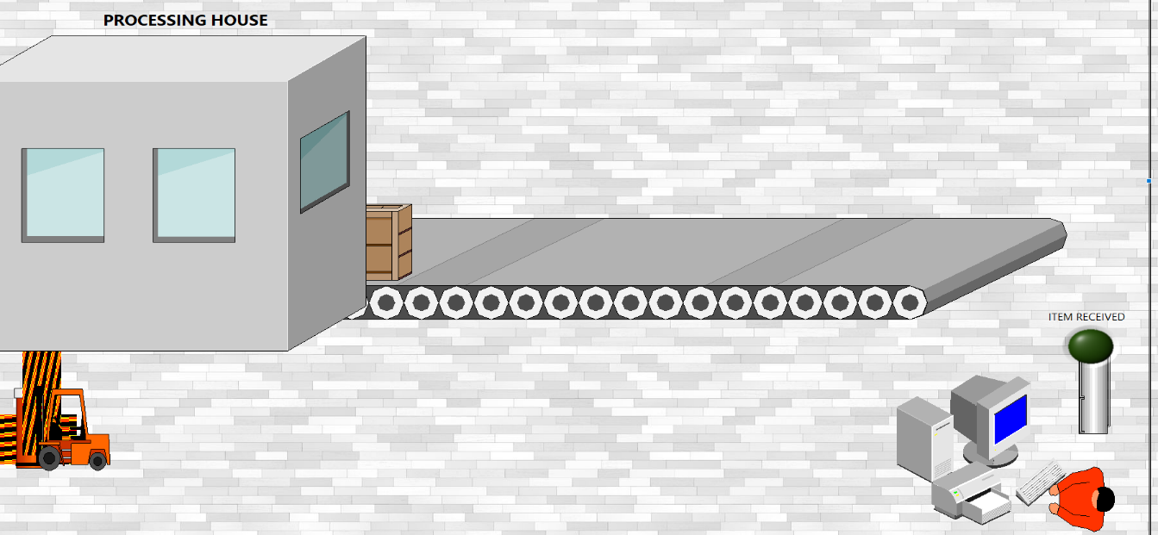

Figure 20 Shipment Process

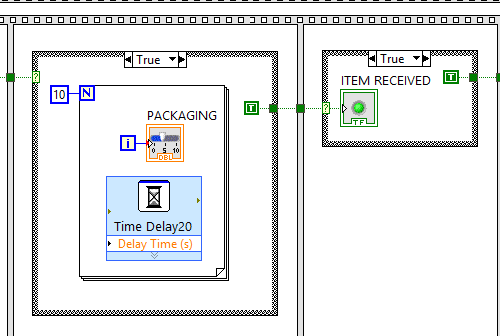

Figure 21 Block Diagram conveyer belt

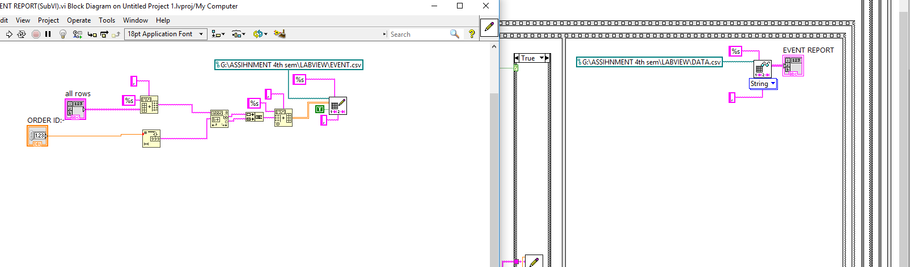

Figure 22 Event report(SubVI)

Security is one of the most important key to run any system and that’s too applied in warehouse management system. In the design three major type of security applied including system hack, robbery alarm and also heat alarm .For this preventive measures is applied in the system for system hack the user can only access to the system unless and until provided the username id and password and also the OTP or One time password sent to his registered number and if the user attempts to unlock more than 3 times by providing wrong information then the system will turn on alarm in every part of the warehouse alarming the system administrator about the hack ,for robbery the cctv been installed and the guards monitors and if any suspect appears he can directly turn on the alarm, if the temperature rises more than the specified temperature it will turn on the alarm, turning on the fire sensor too.

Security panel is made up of Cluster having 3 different data types including String type for message display by the system administrator in case of emergency, Alarm and Security Level are the Boolean types and a thermometer numeric of integer type been used. Also, the

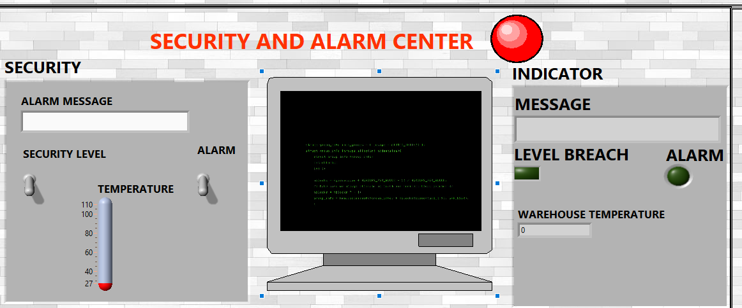

Figure 23 Security Panel

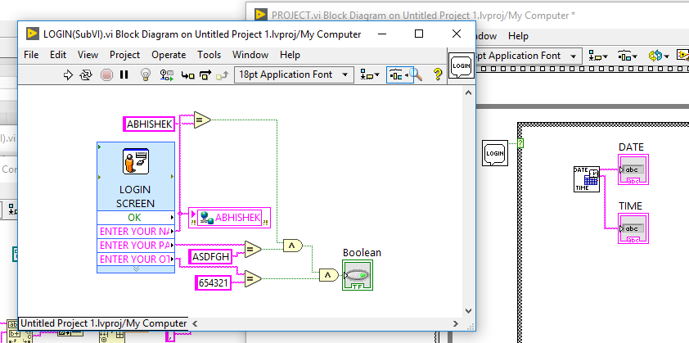

Figure 24 Login Security

Security center works under while loop parallel to main while loop such as to take the benefits of LabVIEW parallel processing (Figure 22)

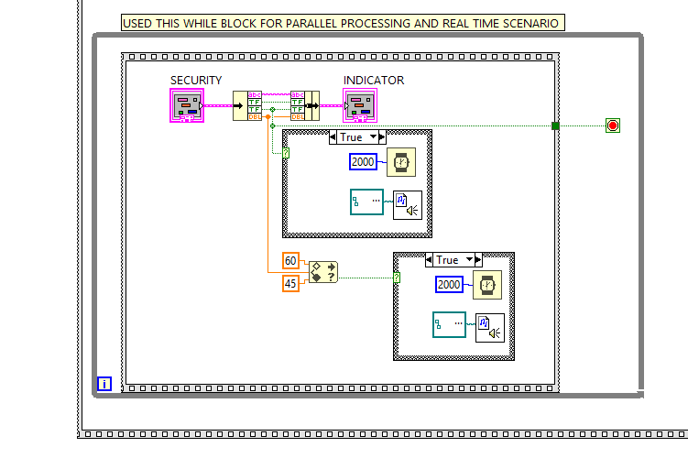

Figure 25 Security center block diagram

A price conversion and Crude oil price indicator (Figure 23) is made in SubVI (Figure 24) using data socket function to show the current price of the Crude oil and also the conversion of 1 USD to Malaysian Ringgit(RM).Data Socket accept the website address as the input and then with the help of id being provided by the program it runs to a match string function where it checks for the string and it display the data next to that using the help of numeric indicator Also, in the panel Date and Time indicator keeps updating with the help of date and time function of LabVIEW which is made in another SubVI(Figure 25).

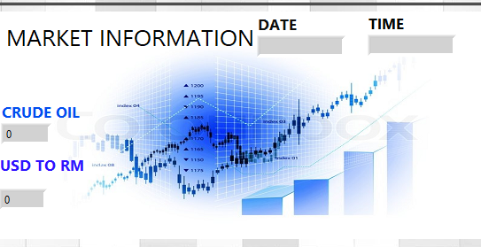

Figure 26 Crude and price conversion

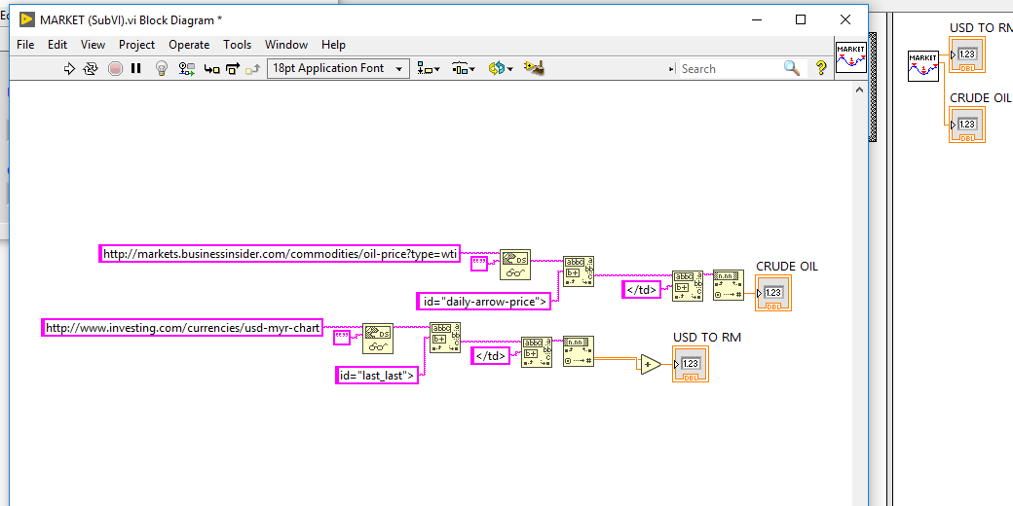

Figure 27 Block diagram of Market SubVI

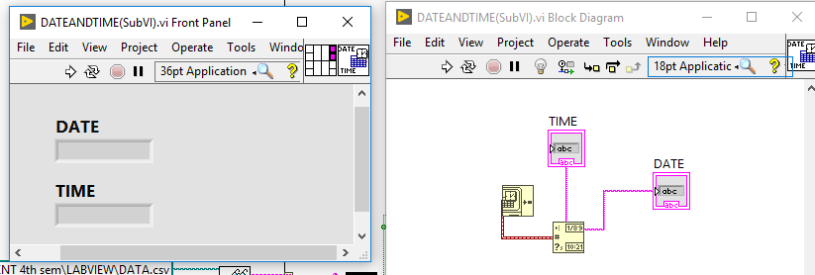

Figure 28 Date and Time SubVI

Web Publishing tool (Figure 27) is used to connect the VI to web such that the process can be monitored anywhere in the world. The process of Web Publishing Tool in which the user selects the vi and then add the document title and then header and footer of the webpage and last process is connection. After the connection been made the output is extension .html page(Figure 26) which can be accessed anywhere in the world.

# 

Figure 29 Web published VI

# 

Figure 30 Web publishing tool

# Discussion

An Automated warehouse works on the design principle of few basic touchstones of warehouse management system which includes path management, process management and certain other benchmarks, keeping this in mind the design being finalized.

Starting with path management designing to simulate the movement of the robot was a task which took the most time because of not having familiar towards Control Vi and the Graphical function’s, but once realized the way of doing it and the logic behind it which was the Horizontal and vertical slider movement and the updating of slider icon with the image it was quite logical and creative thing in the whole design.

Next issue was the sequential programming, most of the process in the design was designed to work one after another or sequentially, and also the functionality of while loop which results in parallel processing in LabVIEW was one good and at the same time a bane for the program because then every task under while loop was running at a same time. This is being sorted out with the help of Flat Sequence function which let program run one after another.

Conditional Loops also known as For loop and While loop one of the most important features in programming world also In LabVIEW was one the most important and in abundant function used in the program. Due to same functionality but different approach for loop in this design came out to be the most important one because of the control of the number of iteration the loop will occur. At the same time the most powerful functionality of the While loop which is parallel processing came out to be the most effective one when dealing with parallel programming in this design the processing house and the Security center uses the while Loop functionality to let both the program run at a same time and if either one stops the program whole system get stopped.

Another major issue was to use the web publishing tool because of the plugin error in internet explorer then after lot of research downgrading the version was one of the way to tackle the problem or rather than using embedded option choosing the Monitor option was another way for resolving the problem.

When the program is too large it’s very hard to debug the error and that’s came to be easy when using flowchart, it’s becomes quite like a flow thing to handle the error as through flow chart it can be traced where the error happens

# Conclusions

The basic Objective of the assignment was to simulate the working environment of Automated Warehouse system. The designed Program or system was a process of forming a conglomerate description of Automated Warehouse. The program successfully demonstrates the basic pillars of the need of an Automated Warehouse in the meantime showing the versatility and functionality of the LabVIEW programming.

With the boom in recent years in the industry in Automated system and also the fast-growing world of online E-commerce, Automated warehouse system is proven to be more efficient and effective than the traditional labor system. And being able to programmed such type of system and demonstrate was quite indispensable. Thus, it can be concluded that the Importance of the LabVIEW and automated warehouse system both being demonstrated Successfully.

**References**

Ni.com. (2018). *Tutorials - National Instruments*. [online] Available at: http://www.ni.com/tutorials/ [Accessed 13 April 2018]

Logistics Middle East. (2018). *REPORT: Robots to dramatically boost logistics by 2020*. [online] Available at: https://www.logisticsmiddleeast.com/article-12659-report-robots-to-dramatically-boost-logistics-by-2020 [Accessed 26 April 2018].

Labviewmakerhub.com. (2018). *LabVIEW Basics [LabVIEW Maker Hub]*. [online] Available at: https://www.labviewmakerhub.com/doku.php?id=learn:tutorials:labview:basics [Accessed 2 May 2018].